**Relax Inc – Take-Home Challenge**

**Exercise Report**

*July 2022*

**Derek Powell**

**Summary:**

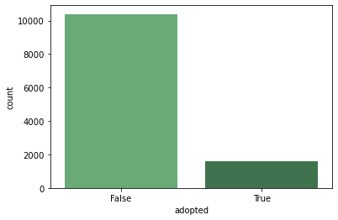***Calculating ‘Adopted’*** – In evaluating the user logins, the first goal was to identify which users were ‘adopted’ users. This required going into the user_engagement table and setting up a function to iterate through the user logins, segregated by a specified user_id, evaluate their logins timestamps, each in relation to the next, and determine if there were 3 logins on different days but within 7 days. This function was to return TRUE if the specified user_id had the required login sequence or FALSE if it didn’t. Using this function, I then iterated through the users table, using each unique user_id to use in the function. In this nested loop, I built a List with a series of True/False values, 12000 values long, one for each user. I then used this List to build a feature into the Users table for ‘Adopted’.

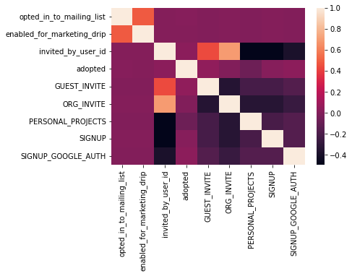***Predicting User Adoption*** – In determining what features best predict future user adoption, I now could subset my users into ‘adopted’ or not, to draw comparisons in their behaviors. I dropped all irrelevant columns and then used one-hot encoding to break out remaining categorical variables. In using a seaborn heatmap, I noted there were very little correlations between ‘adopted’ and the other features.

Running individual countplots, using ‘adoption’ as a hue indicator, I similarly noted few positive correlations in the values. The most we can infer is there is a positive correlation between some invite methods (GUEST_INVITE, SIGNUP, SIGNUP_GOOGLE_AUTH) and 'adoption' rate. These invite methods seem to show greater success, but not substantially so.